Figure 1a


LL
PL
WP
LW
SW
Observation of PU
Intercalary vein

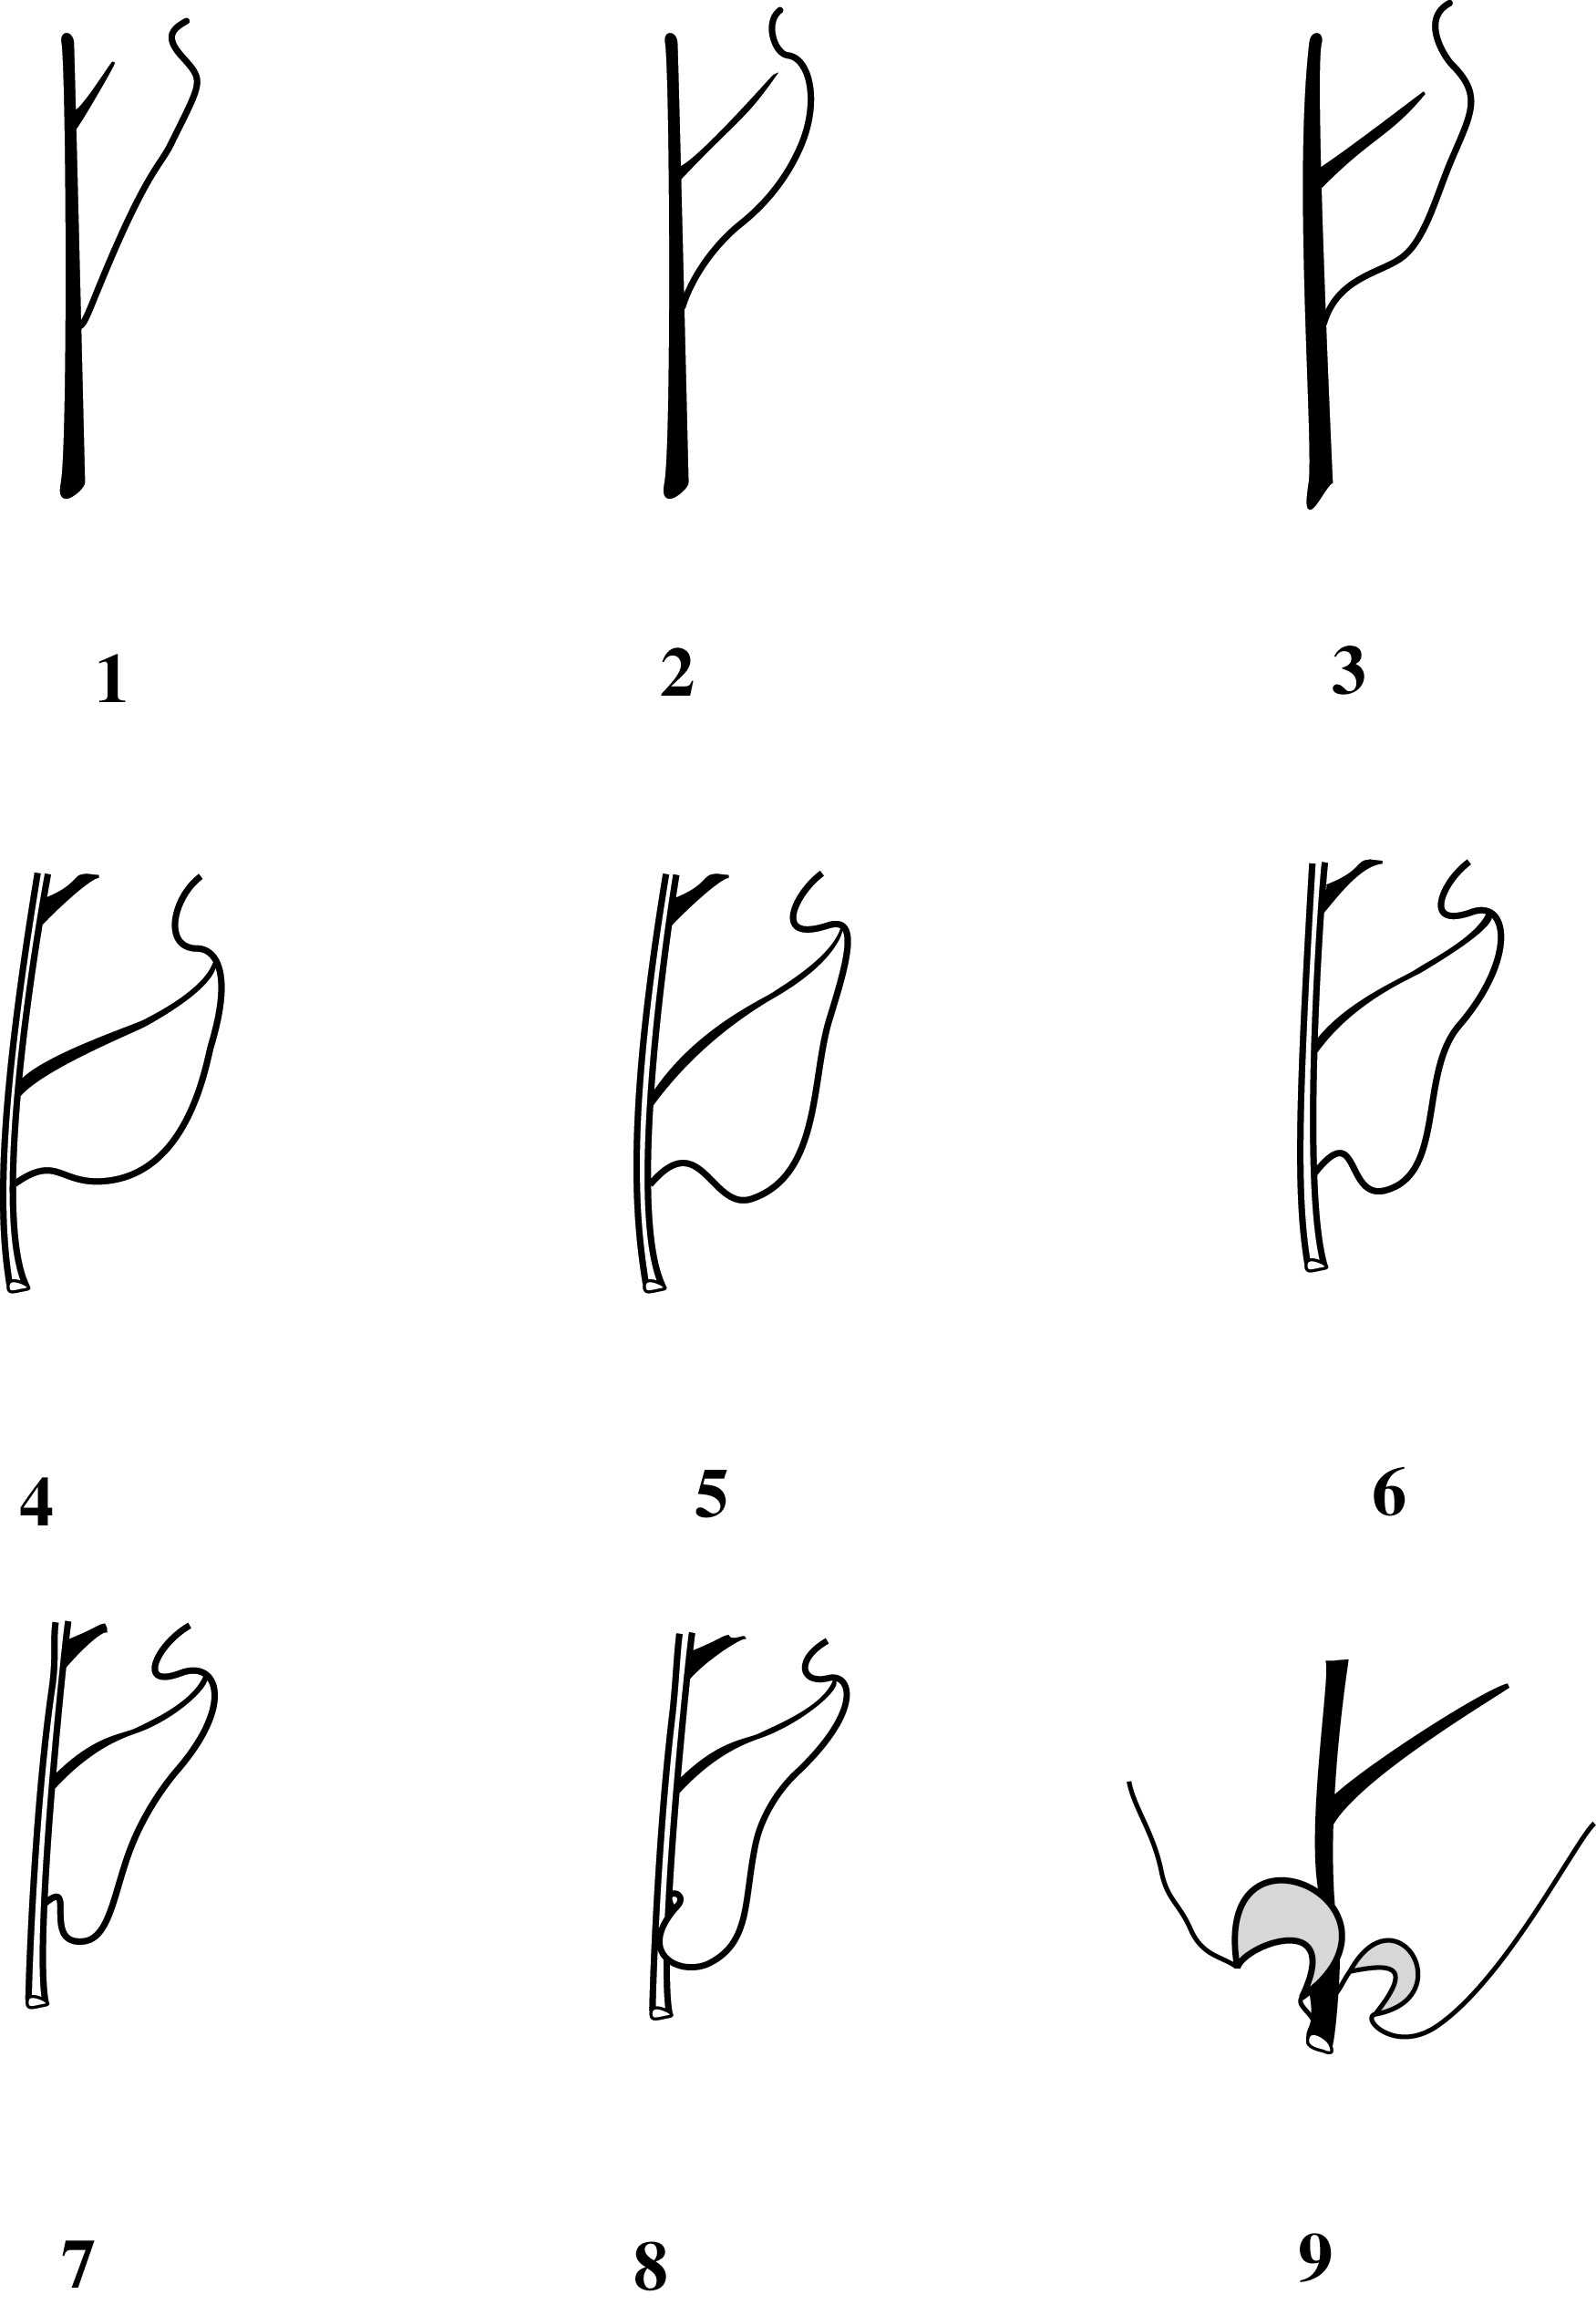

Figure1b

A

C

E
Figure 2
B

D

F

Figure 3

Figure 4

